**CLUES: A letter from the past to the future**

CLUE 1

“I have **nine** brothers” and am **eleven** years old.

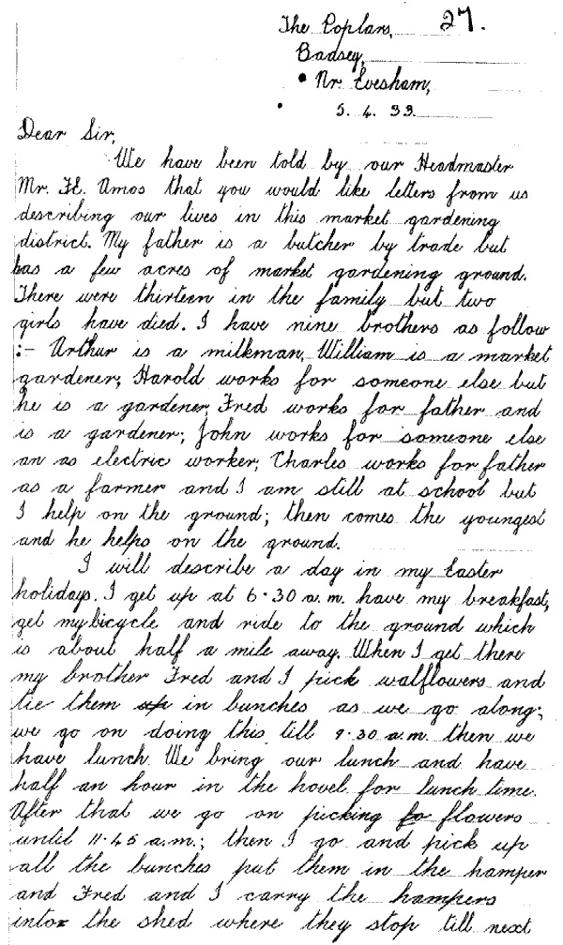

**© Rothamsted Research**



CLUE 2









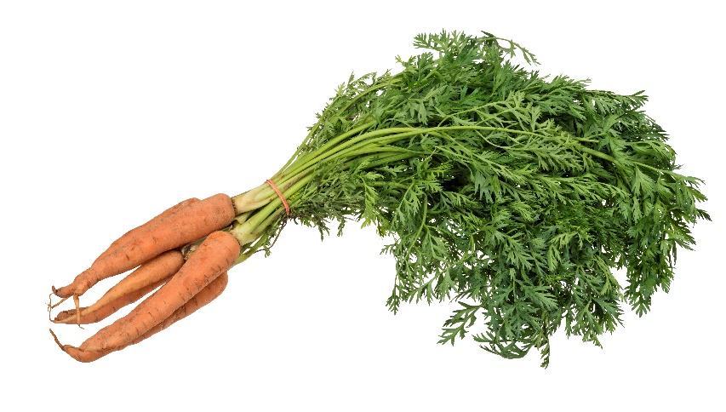CLUE 3

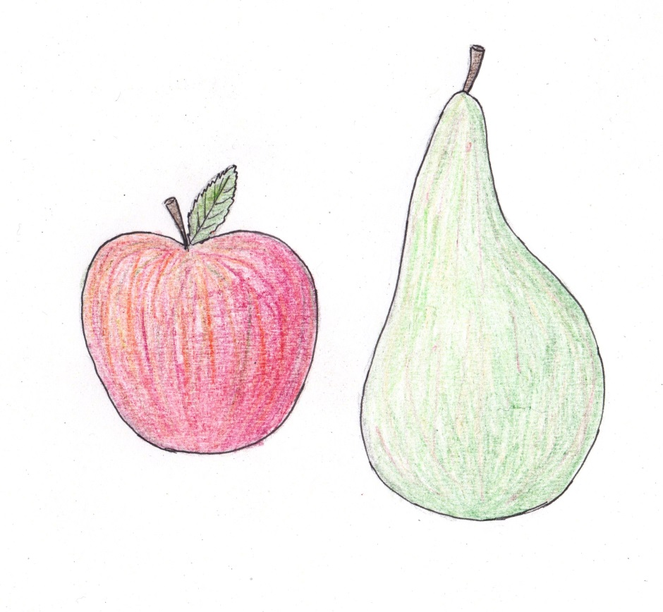

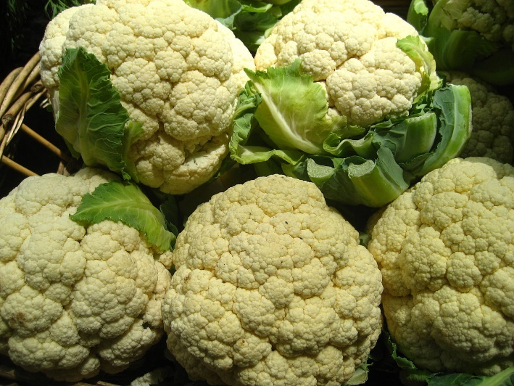

CLUE 4

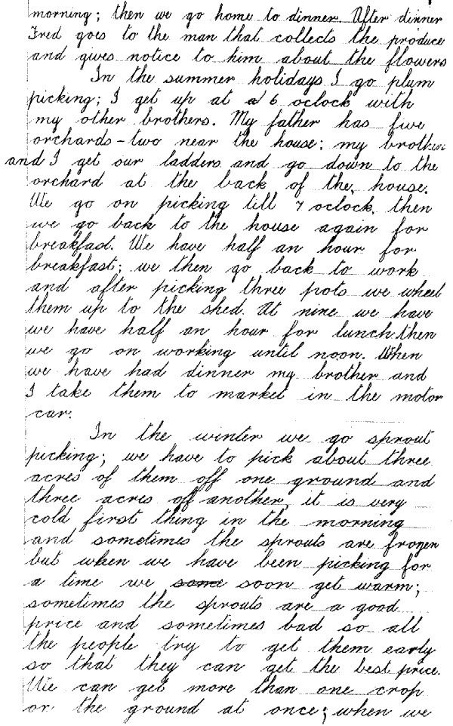

**© Rothamsted Research**

“I will describe a day in my Easter holidays. I get up at **6.30am**, have my breakfast, get my bicycle and ride to the ground which is about half a mile away.”

CLUE 5

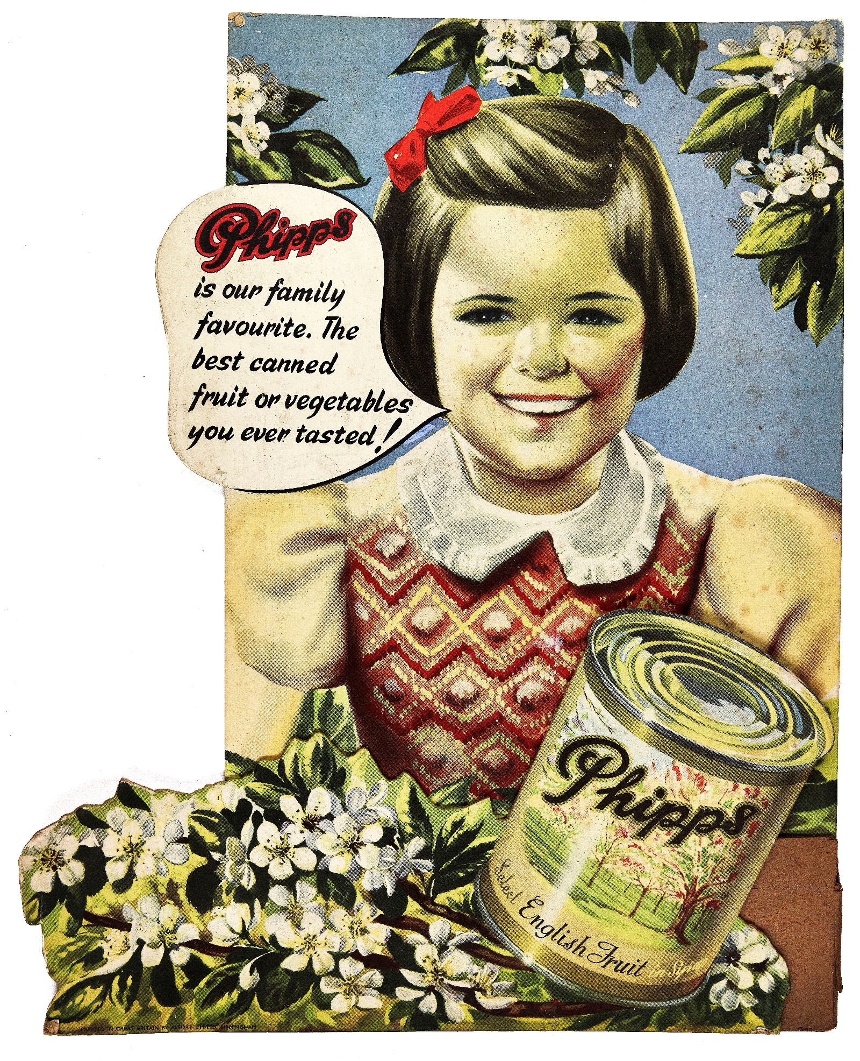

**© Phipps**

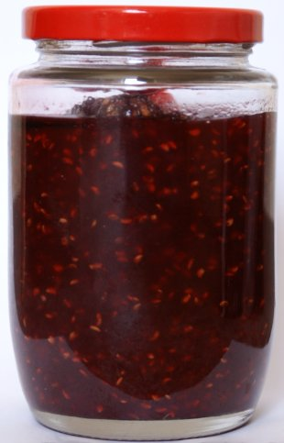

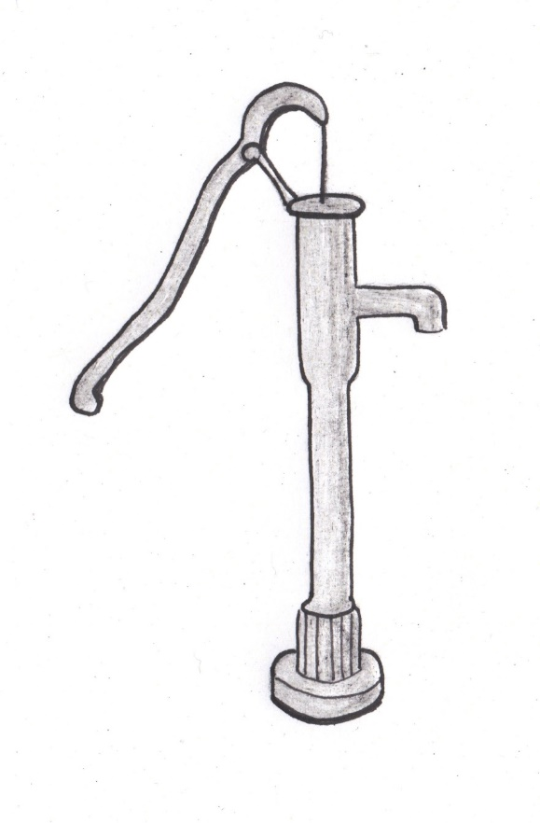

CLUE 6

Water **pump**

CLUE 7

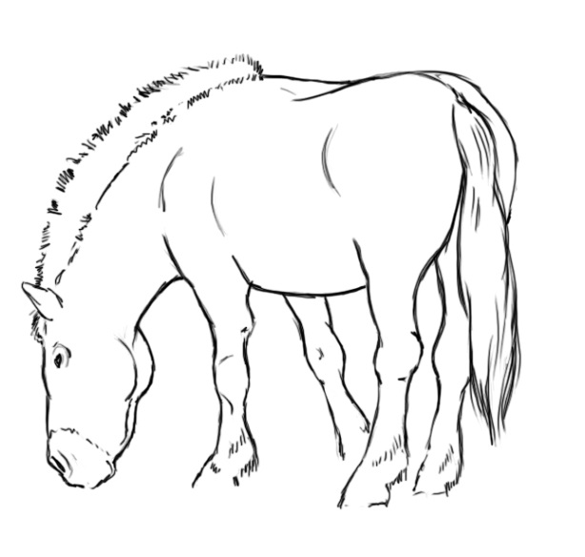

**Steve Rigby ©WCC**

CLUE 8

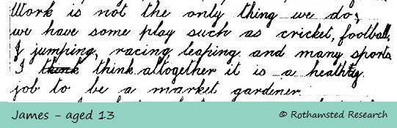

**© Rothamsted Research**

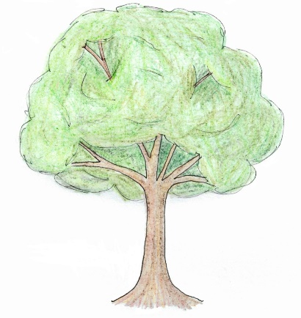

“Work is not the only thing we do,

we have some play such as **cricket, football,**

**jumping, racing, leaping and many sports**.”