CLUES: A letter from WWII to the future

CLUE 1

“I have nine brothers” and am eleven years old.
© Rothamsted Research

CLUE 2

CLUE 3

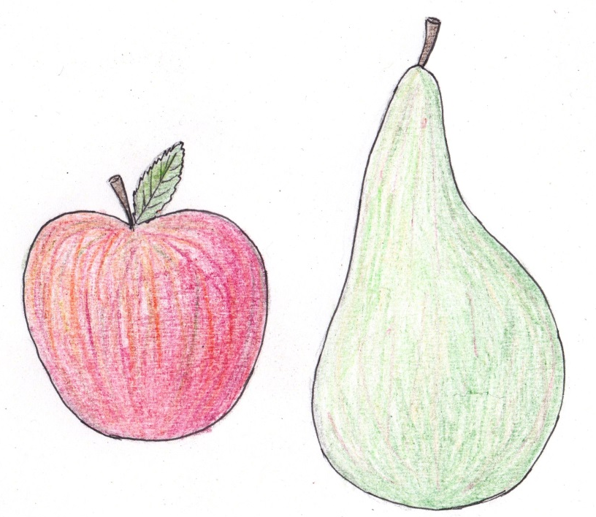

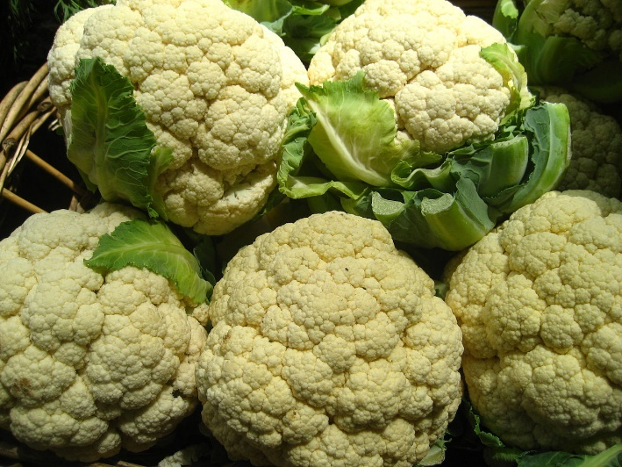

CLUE 4
© Rothamsted Research
“I will describe a day in my Easter holidays. I get up at 6.30am, have my breakfast, get my bicycle and ride to the ground which is about half a mile away.”
CLUE 5

The Second World War began in 1939 and ended in 1945 (the First World War happened 20 years earlier).

Market gardeners, farmers and men with other important jobs did not have to fight.

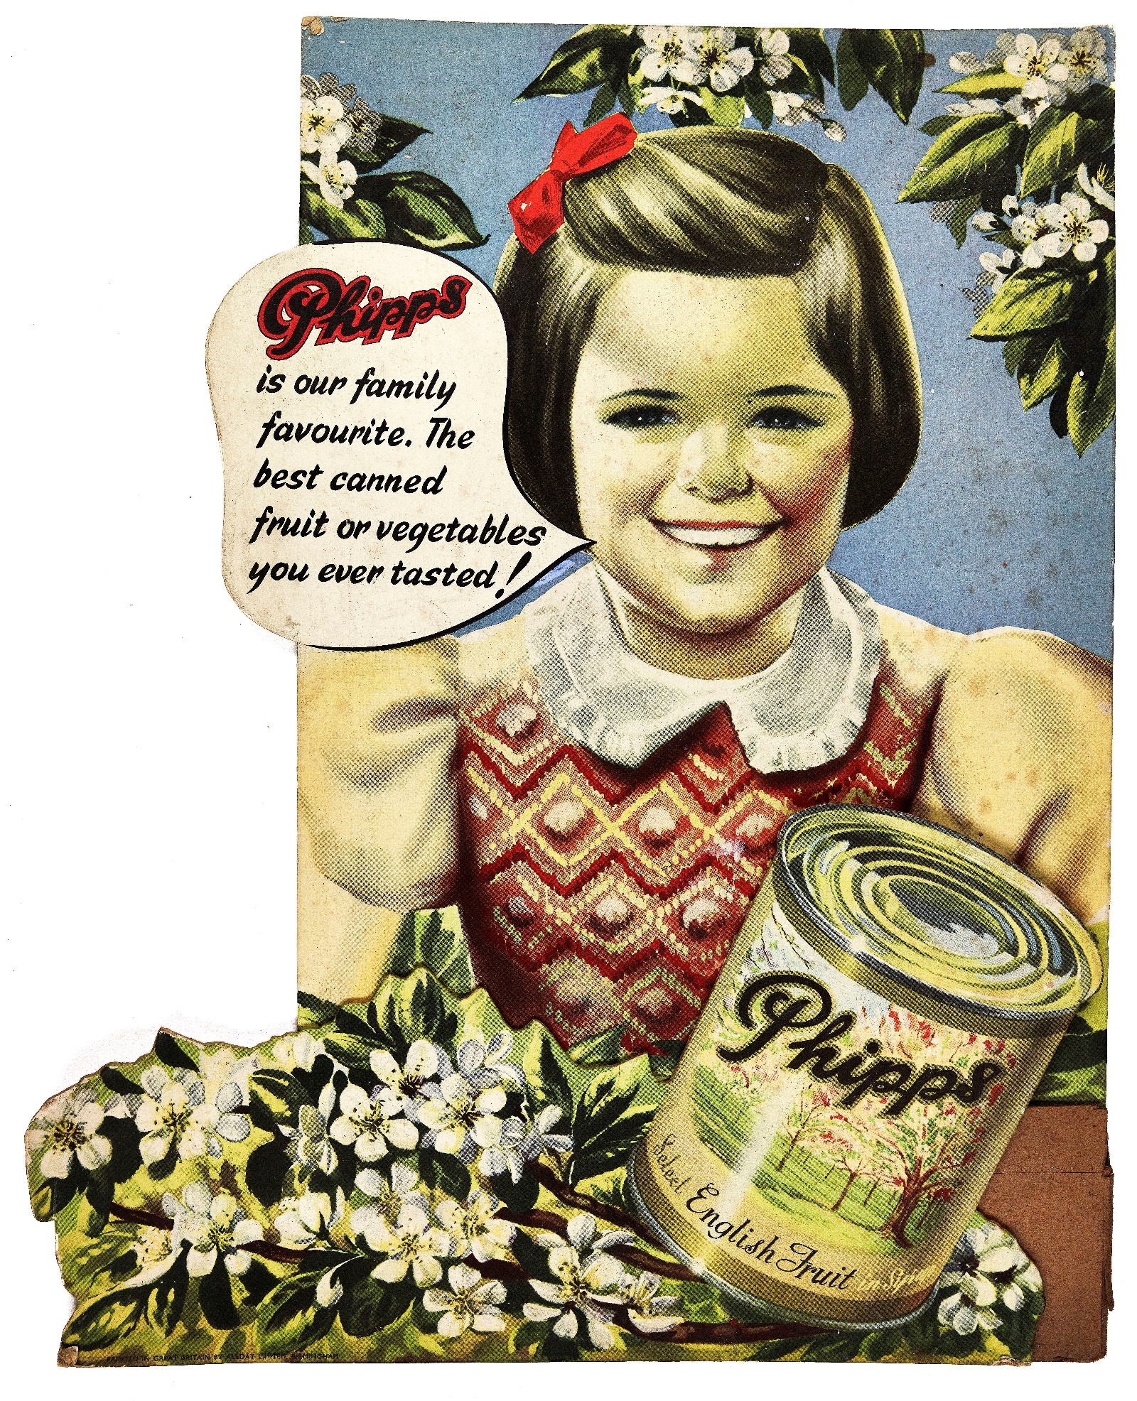
© Phipps
CLUE 6
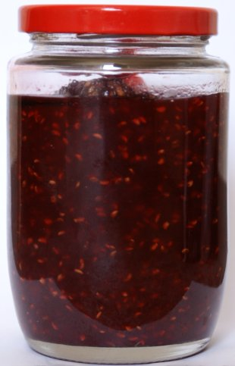
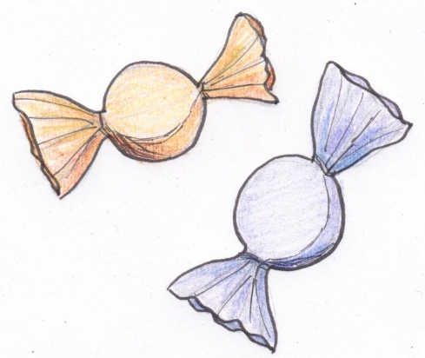

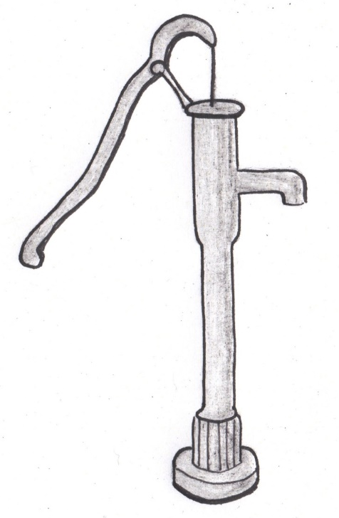
CLUE 7

Water pump

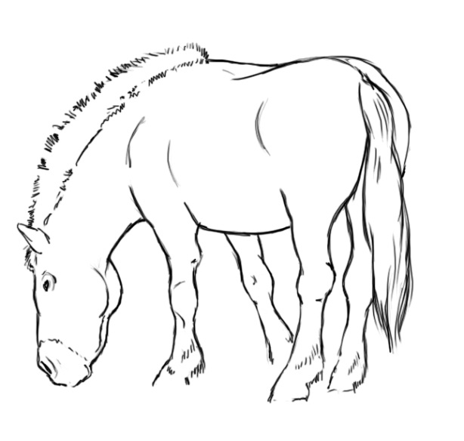
CLUE 8
Steve Rigby ©WCC

CLUE 9
© Rothamsted Research

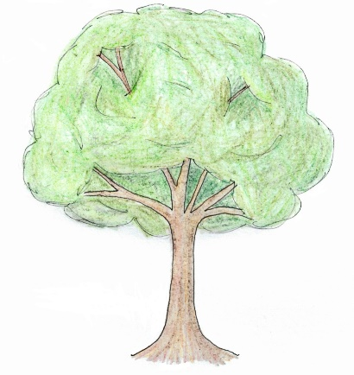
“Work is not the only thing we do,
we have some play such as cricket, football,
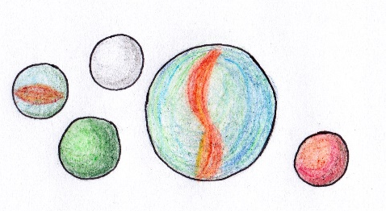
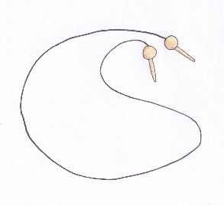
jumping, racing, leaping and many sports.”

