Memories of the Women’s Land Army

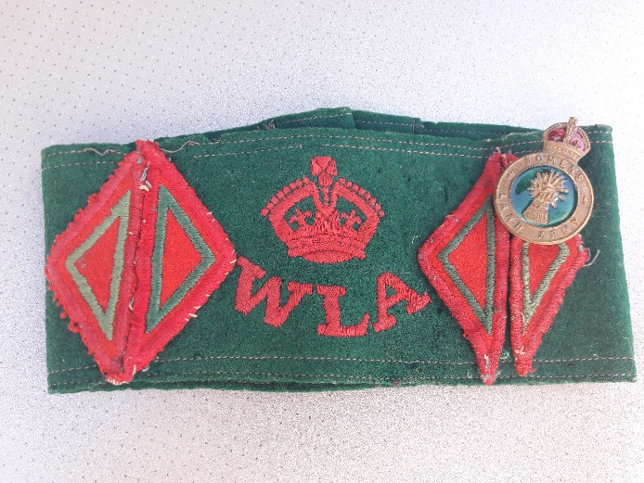
Beryl was born near Birmingham in 1926 and had four brothers and three sisters. During World War II, Beryl worked as a ‘land girl’ in the Vale of Evesham – she was 16½ years old when she joined the Women’s Land Army in May 1943.
This armband was part of Beryl's uniform for the Women's Land Army.

City girls
Over 30 girls, including Beryl, were sent to stay at Wickhamford Manor by the Women’s Land Army. Most of them were from cities and hadn’t worked on the land before. Beryl learnt how to do tasks by trial and error or from the growers and farmers she worked for.
Around 7.15am each morning, lorries would arrive to take groups of land girls to the farm or market garden where help was needed, or they would cycle if it was close by.

A good or bad time?
Early on, Beryl and several other land girls had an unpleasant time working on land that had been left to grow weeds for too long. However, the Simms brothers in Childswickham village had just asked for extra workers, so from then on Beryl’s group spend most of their time working for them. The Simms family grew vegetables and some plums. They were good people to work for, showing the four land girls what to do and giving them extra food to take home at Christmas.

Work in all weathers
A lot of time was spent removing weeds, planting and harvesting potatoes, hay making and packing fruit or vegetables into boxes. Beryl remembers that it was often back-breaking hard work out in all weathers. Sunburn was common during sunnier months, as they weren’t given sunhats and suncream wasn’t used much in Britain at the time.

Food, clothes and washing
Evening meals were cooked for them and the food was generally good. Packed lunches were eaten on the land. Beryl felt that her diet and health got better due to being in the countryside, the exercise and good food.
The manor where they stayed had several shared bedrooms and a large bathroom. Bedding was washed for the land girls, but they had to clean their own clothes and wartime rules meant that bath water had to be shared.

Was it enjoyable or just hard work?
Local people were mostly welcoming and grateful for their help, although Beryl remembers being teased about her weekend trips home.
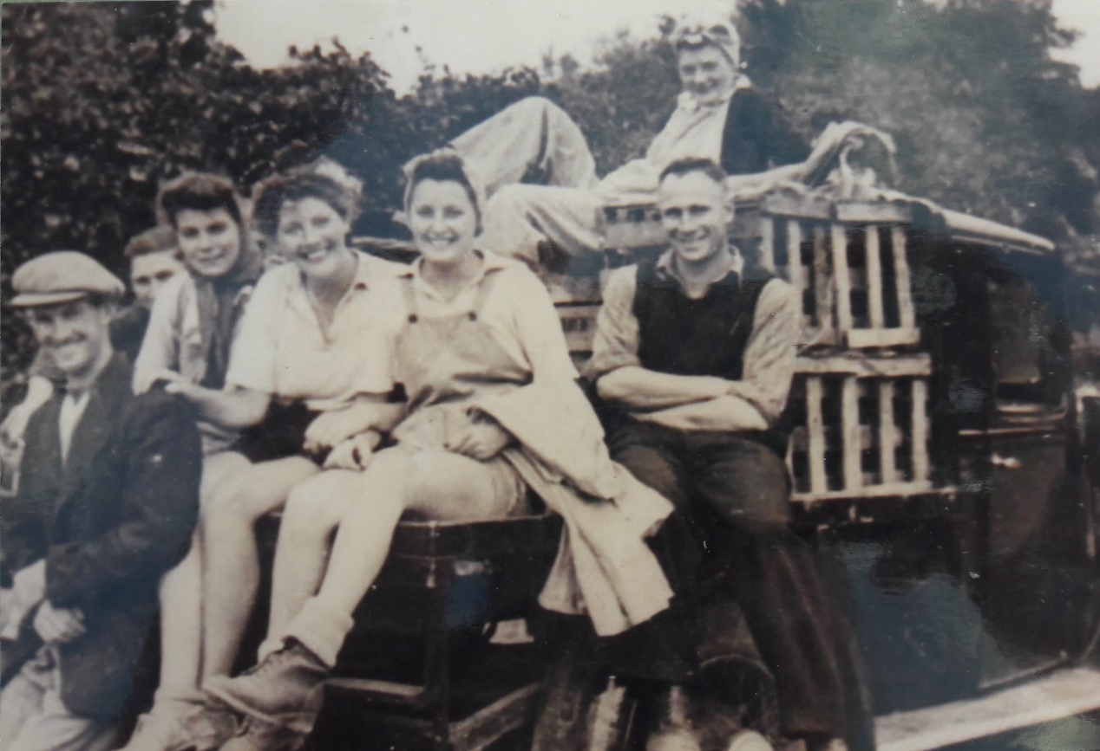
Beryl was in the Land Army for 2 years. Her memories are mostly of the very hard work and cold weather, although they did have fun together and took pride in the part they played to keep Britain fed during the war.
Beryl and friends with the Simms brothers, who they worked for.
This summary of Beryl Redgewell’s memories was written in 2020 for the Market Gardening Heritage project. Photos and information shared with kind permission of Beryl Redgewell.

