Where were market garden crops sold?

Oxstalls Farm address book
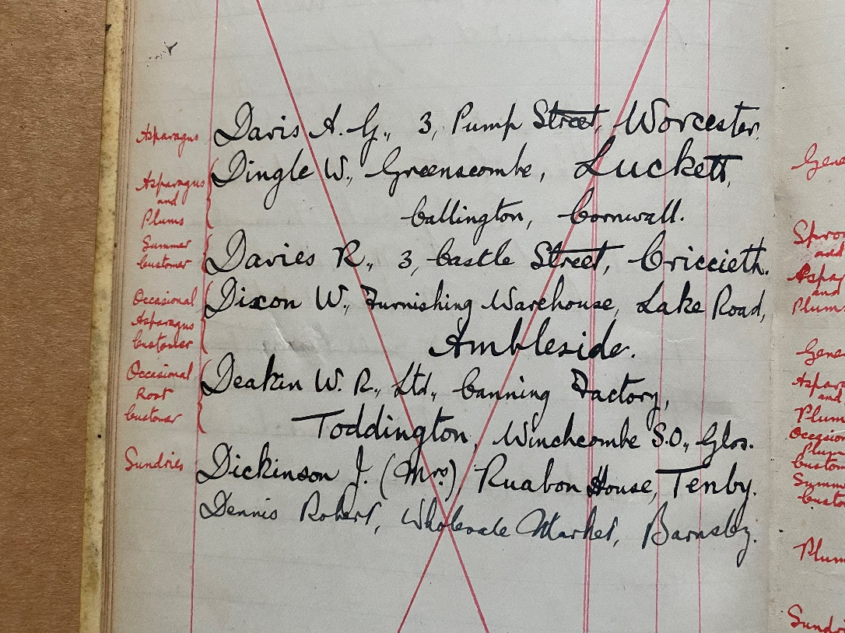
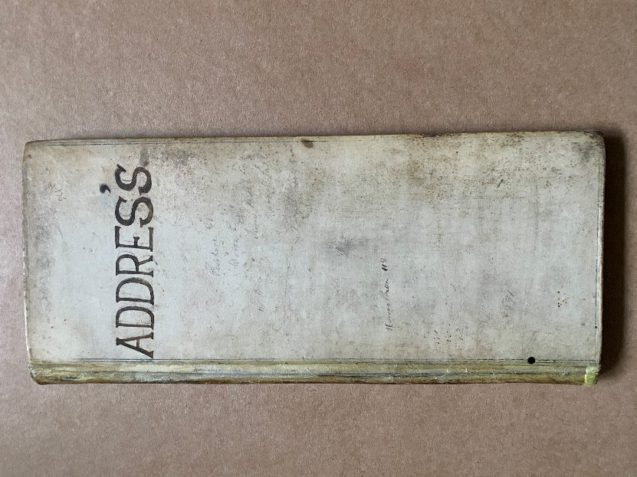
© R Rowland
Photos of the address book for Oxstalls Farm - shared with kind permission of the Rowland family.

This address book lists all of the places across the country where Oxstalls Farm in Evesham sold their fruit, vegetables, herbs and flowers. There is no date in the book, but it’s likely to be from the 1920s or possibly 1930s.
How many different places were food sent to in total? Can you find anywhere that is in Scotland or Wales? Which place is furthest away from your school? A full list is below and an interactive map is on the webpage.

What was sold? | Surname | Location
Any fruit & veg | Bramah | Sheffield
 | Buckley | Malvern Wells
 | Corah | Northfield, Birmingham
 | Deakin Ltd | Toddington
 | Edmonds | Haverfordwest
 | Grundy | Malvern
Any fruit & veg | Griffiths | Mountain Ash
 | Helyor | Bournemouth
 | Jenkins | Pembroke Dock
 | Jones HW | Colwall, Malvern
 | Jones T | Ammanford
 | Jenkins, Alfred | Pembroke Dock
 | Lock and Son | Llandidrod Wells
 | Lord | Pershore
 | Milton | Tonypandy
 | Morgan Bros | Tonyrefail
 | Oakey Bros | Tredegar
 | Oakey Bros | Rhymney
 | Powell | New Tredegar
 | Roberts | Worcester
 | Robson (fruit merchant) | Pontlottyn
 | Ruther TW (fruit merchant) | Blaenavon
 | Ruther S (fruit merchant) | Ebbw Vale
 | Ruther Ted (fruit merchant) | Pontypool
 | Ruther J (fruit merchant) | Aberdare
 | Ruther TW (fruit merchant) | Caerphilly
 | Saysell (fruit merchant) | Blackwood
 | Such W | Redditch
 | Towndrow | Malvern Wells
 | Williams HC | Bristol
 | Williams HC | Cardiff
 | Wildgoose and Son | Matlock
 | Walton | North Malvern
 | Westacott | Dartmouth
Summer fruit & veg | Bennett Bros | Port Talbot
 | Clements | Abertillary
 | Chanin | Minehead
 | Davies | Cricceth
 | Gilbert | Bourton on the Water
Summer fruit & veg | Green | Stow on the Wold
 | Hillier | Shrewsbury
 | Jones | Montgomeryshire
 | Lamb and Reid | Edinburgh
 | Lesslie | Kirkcaldy
 | Matthews | Borth
 | May | Padstow
 | Powell | Barmouth
 | Ruther | Abergavenny
 | Smith | Felixstowe
 | Smith | Frinton on Sea
 | Wheeldon | Cockermouth
Asparagus | Curnow | Nottingham
 | Davis | Worcester
 | Dingle | Cornwall
 | Dixon | Ambleside
 | Govier | Weston Super Mare
 | Goble | Bicester
 | Hebditch | Dorset
 | Smith | West Malvern
Plums | Bayliss | Portland
 | Bowden | Shepton Mallett
 | Brown Brothers | Weston Super Mare
 | Banbury | Newton Abbott
 | Dingle | Cornwall
 | Fare | Dorchester
 | Follett | Devon
 | Govier | Weston Super Mare
 | Goble | Bicester
 | Gillett | Cirencester
 | Grimmer | Thetford
 | Hebditch | Dorsetshire
 | Hicks and Binny | Padstow
Plums | Hawkers Grocery | Chard
 | Isaac Morgan | Cardiganshire
 | Jeffries | Aldeburgh
 | Jessup and Sons | Farnham, Surrey
 | Parkhouse | Plymouth
 | Pople and Porter | Bridgewater
 | Spiller and Son | Exeter
 | Tompsett | Crewkerne
 | Walkey and Company | St Columb, Cornwall
 | Wareham and Arscott | Blandford

