** **

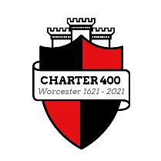

**Worcester Charter 400 Festival**

Project and Essay Competition

Registration Form

The aim of the competition is to encourage people to have a better understanding of your area, place and identity by looking at who or what was important to the City in 1621, and why, and what has developed since 1621 to make Worcester what it is today. You may include maps and images in your finished work, but they must have copyright permission for use if relevant. If you can, provide references and note what sources you have used. The top entries may be published, but these must include references.

Deadline for receiving entries: 5pm Friday 3rd September 2021

**Category: School Years 3-7, aged 8 to 12**

**Prize worth £100**

Name: …………………………………………………………………………………………………………………………….(Please Print)

Age on 31 July 2021: ……………….

Address: …………………………………………………………………………………………..………..

…………………………………………………………………………………………………………….…..

…………………………………………………………………………………………………………………

Email: ……………………………………………………………………………………………………………………………..…

Telephone contact: ………………………………………………………………………………………………………

School: …………………………………………………………………………………………………………………..

What we want you to do:

Your project can take any form and be about anything BUT it must be based on the main organisations, institutions, industries, churches, buildings, charities and people in Worcester around 1621 and why they were important.

**Rules of the Worcester 400 Project Competition**

To enter the competition please fill in the Registration details above and return this page by email to: tourism@worcester.gov.uk

Return the completed Project in hard copy or electronic format to this email or alternatively post or deliver it to

The Tourist information Centre, The Guildhall, High Street, Worcester, WR1 2EY

**Projects may include written work, maps, drawings, images, and at least 1,000 words text. All work should be original and not be subject to copyright issues**

**The completed project will show that you have an understanding of what Worcester was like in 1621 for instance noting the main organisations, institutions, industries, churches, buildings, charities and people in Worcester around that time why they were important.**

The judges’ decision will be final

The decision of the judges will be announced formally on 2 October, Charter Day, 2021

The judges may decide not to award a prize

The prize will be £100 worth of tokens

The closing date for receipt of entries is 3 September 2021

Competition supported by:

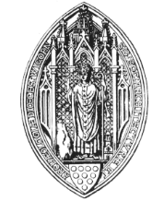Worcestershire Archaeological Society [www.worcestershirearchaeologicalsociety.org.uk](http://www.worcestershirearchaeologicalsociety.org.uk)

 [www.worcestershirehistoricalsociety.co.uk](http://www.worcestershirehistoricalsociety.co.uk)

 <https://www.explorethepast.co.uk/about-us/support-us/>