




Scavenger Hunt
October Half-Term 2025

Have a go at our scavenger hunt throughout October
Can you find these items at home, around town, or in the Hive?

A Wax Seal or a very old stamp   | A map  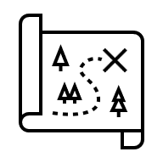
A building with a sign to prove its age | A coin older than you  
The oldest grave in your nearest graveyard   | A local hero  (a statue, street name or plaque)  
An animal  (maybe on a building or a sign)  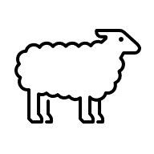 | A magnifying glass  
explorethepast.co.uk

